Distributed Infrastructure in

Afghan Reconstruction and Stabilization

Bottom Line

Distributed, renewable energy can bring essential services to remote areas and contribute significantly to Afghan stabilization and reconstruction, as well as to the counter- insurgency campaign. Such services include water purification, lighting, agricultural activities, and Information and Communications Technology (ICT). Many solutions are available, but they need to be matched to local conditions. It also is important to understand how projects will contribute to sustainable improvements in village life.

Many early microhydro projects had reliability problems, but several successful ap-proaches now can be used as nationwide models. Wind power is starting to be used, but solar still is nascent. Since information sharing about renewable energy is inconsistent, technical training and an information clearinghouse would be very useful.

As local energy projects are implemented, maximum use should be made of national standards to facilitate connections to the overall power grid as it is built-out.

Near-term recommendations include:
- Identify quick-win projects in conjunction with stakeholders. Begin to identify partners through National Solidarity Program (NSP) channels. Afghanistan is a long-term campaign, but pay particular attention to projects that could bring capabilities to people in insurgent-prone areas before snow melt in mid-March to mid-April.
- Leverage the State Department’s work on microhydro power (MHP) in Nangarhar and public health initiatives, building on mobile phone technology.
- Identify innovative approaches and see if any are rapidly deployable in adequate numbers. Test using Naval Postgraduate School/SOCOM/ STAR-TIDES quarterly testing opportunities where feasible.
- Expand capacity-building approaches in Afghanistan in clean energy and related areas to (1) improve indigenous production capacity, (2) encourage entrepreneurial competition, and (3) provide technical training for managers and overseers.
- Find ways to sponsor a technical support unit (TSU) for MHP projects within the NSP framework to enhance technical proficiency and quality control.
- Seriously examine the potential for integrated cooking and solar food processing.
- Integrate distributed energy plans, the build-out of ICT and access to information in remote areas more closely with US and coalition objectives for stability, reconstruction and counterinsurgency.

Table of Contents

Distributed Infrastructure in 1
Afghan Reconstruction and Stabilization 1
Bottom Line 1
Overview 3
Renewable Energy 4
Microhydro Power (MHP) 5
Background 5
Experienced Implementers 6
Existing efforts 7
Sizing and location criteria for power systems 8
Governance 8
Costs and Technical Detail 9
Sustainability 11
Producibility 12
Future Projects 12
Wind 13
Assumptions 15
Solar 16
Hybrids 18
Power Controllers 20
Storage 20
Geothermal 21
Integration 21
Power Uses 22
Water Purification 22
Lighting 24
Agricultural Storage 25
ICT 25
Related Areas 27
Integrated Cooking and Solar Food Processing 27
From Nepal 27
From India 28
Other Initiatives 34
Way ahead 34
Next Steps 35
Summary 35
Personnel Associated with Renewable Energy in Afghanistan 37

Overview
This paper is based on a visit to Afghanistan in January 2009, and related discussions. One purpose of the mission was to look at combinations of renewable energy (microhydro, solar, wind and geothermal) that could provide isolated villages with essential services such as water purification, lighting, agricultural storage and processing, and Information and Communications Technology (ICT).

An Afghan Clean Energy Program (ACEP) is beginning under USAID auspices. According to a recent ACEP concept paper, “only 10-12 percent of the Afghan population has access to electricity, one of the lowest in the world. 340,000 customers are connected to the public power grid, of which 182,000 are in the Kabul area. The other provinces have far less access to electricity, with rural areas being virtually unserved.” Other estimates hold that some 14,000 Afghan villages don't now have power. The population of these villages typically is between 100 and 3,000, but some of the distributed energy approaches in this paper also could be used for urban neighborhoods (population, say, 500 to 20,000).

Many solutions have been proposed, and there are experienced people who can help execute them effectively, but Afghanistan’s nationwide track record in implementing renewable energy hasn’t been very good (by some accounts, less than 10% of microhydro projects still are working after a year or two). Knowledge sharing, training and technical support will be essential going forward.

A key point is to get local “buy-in,” both to meet Afghan needs as they perceive them (not what outsiders think they should have) and to make the infrastructure more resilient to disruption. Thus, the focus is intended to be "bottom up," starting with local governance structures, supported by technically qualified staff. Due to experience with the STAR-TIDES research project, National Solidarity Program (NSP), Institute for State Effectiveness (ISE), Rotary Club and other activities in Nangarhar province, much of this report focuses on that geographic area, but it can be extended to other provinces (and countries) as well.

The Naval Postgraduate School (NPS) at Monterey, California has offered opportunities to test renewable energy systems and related applications at facilities around the US in conjunction with the US Special Operations Command (SOCOM). The first tests were held in mid-February 2009, and the results will be posted shortly to the STAR-TIDES website. Other tests will be scheduled at roughly quarterly intervals.

Renewable Energy

Reliable energy is a prerequisite for development and reconstruction, and thus for stabilization. A number of major energy projects are underway in Afghanistan, such as the Northeast Power System (NEPS) that will provide 20-25% of the power needs of the region, and comparable programs for the west and southeast By contrast, renewable energy provides a way to get power to remote villages fairly quickly, at relatively low cost. Some of the large wind farm projects that are under discussion would become a core part of the power grid, but renewable energy is more a way to anticipate the build-out of the grid and supplement it, than to expand the high capacity grid itself. Nonetheless, it can make important contributions to the well-being of the Afghan people by providing key services to those who haven’t had them.

An important principle for making infrastructures more resilient is that the owners, protectors and users of those infrastructures should be the same people, insofar as possible. This is particularly true in times of lawlessness or insurgency. Village-focused, distributed power projects satisfy those criteria.

Microhydro Power (MHP)

Background

Since most of rural Afghanistan has no access to a power grid, and water resources are abundant, many villages have asked the NSP for microhydro power (MHP) projects. The result has been a “mini boom for MHP-related services in the country (project design, equipment manufacturing etc).”

Between the start of the NSP and 2006 more than 300 MHP projects were either started or completed throughout 22 provinces. But MHP projects are complex and hard to implement, and technical quality control has been a major challenge. On the other hand, the NSP’s use of village-based Community Development Councils (CDCs) is building local capacity to ensure adequate resources are available “on the ground” for the effective operation & management of MHP projects.

Because of this capacity-building, a survey in 2005-2006 found that technical shortfalls in Afghanistan were more a problem than weaknesses in the indigenous ability to operate and manage MHP projects. This is because demand often has exceeded Afghanistan’s local manufacturing and engineering capacity. Also, due to the limited experience and know-how of equipment manufacturers, engineers with the Oversight Consultant (OC), and Facilitating Partners (FPs), many of the MHP projects have not met minimum technical standards to ensure best performance and long term sustainability. The review concluded that there was a:
- Lack of specific knowledge about the design of civil structures and hydro-mechanical components
- Low level / poor technology applied in the manufacture and supply of electromechanical equipment
- Overly ambitious plans for schemes of a size and difficulty level exceeding the technical capacity of the CDCs, FP engineers and equipment suppliers

The report noted: “The fact that so many mistakes are still able to happen even with the NSP approval procedures being enforced implies that the overall lack of specific MHP know how is not only a problem at the contractor and FP level, but also among the OC engineers themselves.” At one point, as an emergency measure, NSP temporarily suspended all FPs from implementing MHP projects. The suspensions were only released after individual FPs satisfied the NSP that they were technically competent to undertake MHP projects.

Expertise has improved since 2006 in at least some provinces, but the nation-wide picture isn’t clear.

Experienced Implementers

Several teams and individuals have experience to implement effective microhydro projects in Afghanistan. To cite but three:

- Chris Corsten (chriscorsten@hotmail.com, Skype--chriscorsten) is the international advisor for a US State Department-funded counter narcotics team doing small projects (almost exclusively microhydro) combating poppy production in rural areas of Nangarhar province. He’s been in Nangarhar for three of the last four years and will continue for at least another year. Chris’s team has implemented several very successful projects, and they have become subject matter experts on microhydro in Nangarhar, and adjacent areas. Their current role is to find every microhydro site possible in the province, from 5 kW systems to 100+ kW systems.
- Mark Hayton (mark.hayton@entec.ch) completed a detailed analysis in 2005-06 of MHP projects in Parwan and Pansheer provinces and five manufacturing workshops in Parwan and Kabul. His focus was in two main dimensions: (1) why local companies aren't scaling (2) why machinery and installations aren’t working. His work also draws on experiences in Indonesia and Nepal. He expects to visit Afghanistan again during 2009.
- Tony Woods (twoods@sesa.af), from Sustainable Energy Services Afghanistan (SESA), has been working on hydro-electric and wind projects in Pakistan, Nepal and Afghanistan since the early 1990s, including technical training for engineers and the formation of energy cooperatives. Currently he’s engaged with an effort called TZA (Tolo-e Zanan-e Afghanistan) which includes solar lighting, solar cooking, and women’s empowerment. He’s skeptical about excessive reliance on the view that “indigenous and low cost must be better.” For example, if imported turbines for microhydro are the same price as local models, but twice as reliable, why not use them and incentivize indigenous manufacturers to do better? He also supports projects that meet existing national standards since the power grid eventually will need a critical mass of commercial products with interchangeable parts (as Afghanistan’s cell phone industry has reached) and, without compatible energy networks, there will be great technical problems in 15 years or so in connecting different villages and regions.

Other planning resources are available through the US Department of Energy’s (DoE) Hydropower Program website at: http://hydropower.inl.gov/techtransfer/. Although these documents are rather dated, the basic principles discussed are still applicable. Another microhydro development guide produced by Natural Resources Canada (2004) is accessible at: http://www.canren.gc.ca/prod_serv/index.asp?CaId=196&PgId=1303 . The bibliography of this more up-to-date document has additional useful information sources.
For Afghanistan, the concept of using pumps as turbines also could be attractive. DoE’s Idaho National Laboratory (INL) recently conducted a resource assessment of U.S. natural streams in conjunction with the US Geological Survey (USGS). The results of this assessment are available in a GIS application on the Internet called the Virtual Hydropower Prospector. The report, Feasibility Assessment of the Water Energy Resources of the United States for New Low Power and Small Hydro Classes of Hydroelectric Plants, January 2006 is accessible at: http://hydropower.inl.gov/resourceassessment/ and the Prospector is accessible at: http://hydropower.inl.gov/prospector/. Even though designed for the US, conceptually they could be replicated for Afghanistan to facilitate electrification.

Existing efforts

There seem to be between 28 and 75 microhydro projects in Nangarhar province. A spreadsheet provided by a combination of the NSP and the Ministry of Rural Rehabilitation and Development (MRRD) in 2008, outlined 72 projects, most not yet started. Chris Corsten has separately published an overlay to Google Earth that identifies 28 functioning projects (17 working well, 11 that could be improved), plus more than 100 potential ones. Some of these overlap with the NSP list, some don’t.

Sizing and location criteria for power systems

MHP systems in Afghanistan usually provide between 3 kW and 100 kW of power, more typically between 5 kW and 50 kW, although one project in the NSP-MRRD spreadsheet is 171.1kW. The 100 kW units typically are high in the mountains and often in Taliban-prone areas. There is huge MHP potential in the Dara-I-Nur district. It’s mountainous, with terraced valleys, and probably could host about 50 sites, including the ones already there. The Achin district has 47 possible sites: 3-5-20-100 KW.
The place to set up an MHP project is wherever that kind of solution works. Typically there won’t be enough power for everyone in a village, so the shura will have to decide who gets what. Each kW can light about 20 houses (with compact fluorescent bulbs). Lighting is the first thing people want.

Governance

The NSP is implemented through the MRRD. A CDC can submit proposals for village infrastructure projects drawing on NSP funds. They are entitled to receive total funding of US$200 per household with the maximum village size totaling 300. Since the start of the project in 2003, NSP has supported more than 35,000 sub-projects in over 20,000 communities throughout all 34 provinces in the country. Between 2003 and 20O6 the project absorbed US$ 800 million of which block grants provided to the villages represented approximately 50% of the total budget.

Most of Chris Corsten’s efforts are being built as community development projects, in reward for poppy reduction. They’re not being done through NSP, but use a similar model of governance by shuras and village councils. A committee within the Government of the Islamic Republic of Afghanistan (GIRoA) oversees his projects (since his team is a State Department International Narcotics and Law Enforcement (INL) counternarcotics (CN) group with couple million dollars to spend). The oversight team includes representatives from Agriculture, CN, the provincial council, MRRD, etc. However, the oversight often is not very helpful and leads to projects being stalled, stopped, funds diverted, etc. Corruption can be a problem as well.

One problem is that many projects are built on the basis of “what do you want?” where those who yell loudest get their wishes. For example, a retaining wall recently was built around a school even though the irrigation system was bad. Instead of asking “What do you want?” a better way would be to empower the government by providing a thorough survey of local opportunities that says: “This is the full potential of what’s out there. How would you prioritize?” An important part of the sociology, for any kind of project, is to make the information available in ways that are respectful of, and informative for, the leaders, rather than making them look ignorant in the eyes of their constituents.

Due to personnel turn-over in various US government offices, compared with the continuity of people on Chris’ team, consideration should be given to having Chris and his team take the lead for the small microhydro efforts in Nangarhar. His engineers have whole project engineering specs, which came out of NSP, and all data are available. Information-sharing approaches will be very important.

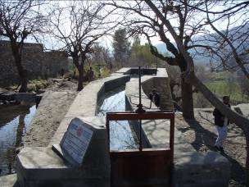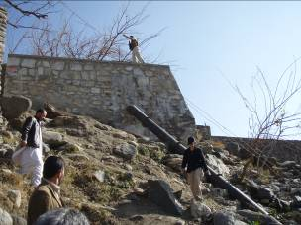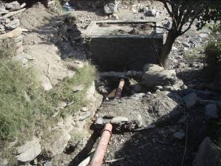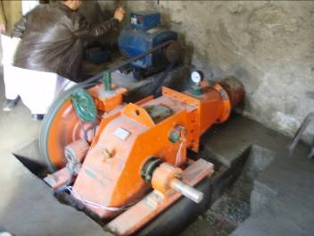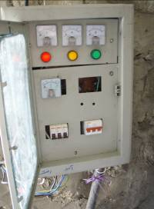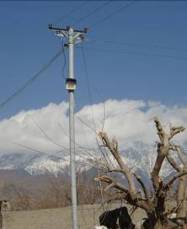
Component Parts of a Microhydro System
Canal and Forebay
Penstock to Powerhouse
Penstock to Powerhouse
Turbine Turns Generator
Power Fusebox
Power Distribution
Source: Chris Corsten brief: “Microhydro Power in Nangarhar”

Costs and Technical Detail

As shown in the illustration above, an MHP system consists of a canal, forebay (pool for holding water), penstock (water ducting) to the turbine and a belt to the generator. Other elements include trash racks at the entrance to the penstock to keep debris from entering the ducting, guide vanes and flow-adjustment facilities to keep water flowing through the turbines even under low water conditions, and generator foundations. The turbine is a steel wheel and is pretty resilient, but fuses and governors need watching to keep the generator from overloading. Electronic load controllers have been hard to maintain up to now, but new designs look promising.
The costs per kW in the NSP-MRRD spreadsheet vary considerably:
- From $115/kW for 171.1 kW (Surkhd Rod district, Bazeed Khil—item #52), to $348/ kW for 7 kW (Achin district, Neem Perokhil—item #35), to $4,448/kW for 12 kW (Chaparhar district, Soulouzay—item #9).
- Within a single district (Bihsud), the estimate at Tangi Toghchi (#43) is $439/kW for 15.63 kW, while the same 15.63 kW at Dar Wazgi (#44) is estimated at $1,385/kW.
KW per capita also vary considerably: Several projects provide less than 20W/person, e.g. in Chaparhar district, the Dago Manz Kaly 2 (#6) generates 6W per person, 26W per family, but others offer considerably more, with the peak at Bazeed Khil (#52) with 312W/person and 1,752 W/family.
The main cost variable is how much construction needs to be done to divert the water. The most expensive single component is the turbine, but setting up the canal, and building the forebay usually are the most costly overall elements due to the stone masonry work and how far the materials need to be transported. A 40 kW system could cost less than a 10 kW one.

In many CDC projects, equipment typically was supplied at costs of $1000/kW (electro-mechanical equipment and 3 km of power lines), with CDC payment calculations of $200/family in 2005. In some villages, consumers pay tariffs of Afs 50 per 5-20 watt fluorescent light bulbs. Others pay Afs 10/kwh, which equates to about Afs 1000/mo. Power meters, at about $15 each, are good investments that help avoid arguments and provide the extra funds for well-run village organizations to cover operations and maintenance costs and unexpected expenses. Training should include resource management skills.

The State INL Counternarcotics projects are rewards to Afghans for stopping poppies—no outside contractors are used. A rough estimate is $20-$30k per project with good masonry, power lines in steel or aluminum tubes, etc. Some engineers say they can build a system for $5K, but that would be very flimsy, and unlikely to last. On the other hand, traditional approaches using contractors could run as high as $120k due to the use of high priced labor, etc.

A minimum pressure head of 5 meters usually is needed for the MHP equipment available in Afghanistan. There also are low-velocity, high-volume turbines that are optimized for slowly flowing rivers. For example, the Western Hemisphere Information Exchange (WHIX) program at Florida International University (FIU) has 1.5-to-2 kW microhydro units optimized for either approach. However, since Chris’ units aren’t being built on the main rivers, but rather on the streams and side washes, they’ve been more focused on high velocity, low volume.

The equations for microhydro infrastructures are:
(1) Turbine Size (output in kW) = G x CoR x Hn x Q, where
G= gravity 9.81 (m/sec)
CoR= Coefficient of resistance (Chris Corsten’s team uses 0.6)
Hn= Net Height (m)
Q= Quantity of Water (m^3 /s)
Q is measured by taking the cross-sectional area (depth times width) of the canal (A) that feeds the microhydro unit and then measuring the velocity (in m/s) by putting a float in the water and seeing how long it takes to go 10 meters (B). Q = A x B.
Since the mass of 1 cubic meter of water is about 1000 kg, the output is in kW.
(2) Generator Size = 125% of turbine size, so a 20 kW turbine would be matched with a 25 kW generator. If there are multiple generators on a single turbine, each should be downsized so they collectively add up to 125% of the turbine rating.

In one successful system, a discharge (Q) of 800 liters/sec (.8 cu meters/sec) and a head (Hn) of 5.5 meters produced 20 kW. This equates well with the formula, which would have yielded 25.9 kW.

A 5 kW turbine is about 1m long by ½ m wide and weighs a couple hundred pounds.

There also are very low cost, low power MHP systems (built around 10-gallon buckets, with vanes made of PVC pipe, driving things like Toyota alternators as generators) that are being used in Southeast Asia to light schools or other small facilities for a few hundred dollars per unit. Chris noted that something like that could work in Afghanistan, but that Afghan schools usually were not built close to streams due to flooding.

Sustainability

It’s been reported that many (most?) microhydro installations in Afghanistan have had problems within a year or two. Chris is sure that his team’s designs will last for a long time. His engineers have worked for NSP, and are good. If the systems are built right, and have the right mechanisms to protect them against variations in water level and generator overload, they should last at least 5-10 years. The most likely component needing replacement would be the generator, which could be overloaded. Chinese (or Pakistani) generators cost about $400, roughly 1/5 the price of Japanese ones. They’re not as good, but the villages have some chance of being able to raise the money to replace the regional ones if they go bad. Chris’s team thus went with the Chinese generators, but were criticized by the GIRoA, which wanted the more expensive ones, even though there was no chance of the village being able to buy replacements if they broke.

Villages typically are within 2 km of a generator, but a 40-50 kW system could power 4-5 villages, which implies longer wiring runs. If the projects are coordinated well with the shuras and district development councils, they’ll be protected.

In Indonesia, a Technical Support Unit (TSU) was set up to provide engineering expertise for multiple MHP projects. A similar approach has been suggested for Afghanistan to provide a continuous technical capability for projects across the country, independent of personnel rotations. Training also needs to be put in place for personnel in the Renewable Energy Department at the MEW. If national standards are incorporated into the initial phases of remote initiatives, it will be easier later to integrate the villages into regional projects.

Producibility
From an indigenous Afghan production perspective, turbines are the hardest manufacturing challenge. There was only one good machine shop building them in Jalalabad as of 2008, although Mark Hayton had identified several machine shops in Kabul and Parwan in 2005-6. Some of the turbine designs are becoming standardized, such as the “Hindu Kush” cross-flow turbine, and new designs are being introduced. This is an area where systematic training and encouragement of entrepreneurial competition could be very useful.

At this stage, nearly all generators must be purchased from Pakistan (or China). The other materials for MHP projects can be gotten in the local markets.

Future Projects

Chris and his team believe there are over 200 possible MHP sites in Nangarhar, which could generate a total of a couple of megawatts (see discussion below and the potential sites in Chris’s Google Earth overlay, as caveated in the footnote).

A robust MHP program for Nangarhar province probably could be completed for under $10 million, with a few engineers. This could produce about 100 MHP projects which would generate a few mW--enough to light up the whole southern border of Nangahar, a negligible cost compared to the return. Between the major rivers around Jalalabad the terrain is flat, but power could be generated through drainage off the grand irrigation canal. The calculation for the provincial project was as follows:
- Generators, turbines and sites: A complete program for the province would include a few 50-100 kW units, about thirty 20-40 kW units, and about 100 5-10 kW systems. With a very aggressive approach, 100 could be built in a year, if there’s no interference once the projects start. Estimate an average of $50k each to allow for more expensive installations at remote sites. The total would be $5m for generators, turbines and site preparations.
- Afghan engineers: 2 engineers per district, spread over 10 districts at a time = 20 engineers at $1000/mo= $240k for engineers.
- Vehicles: 15 vehicles x $1000/mo rental x 12 mo = $180k.
- Office expenses: $7k/mo = $84k.
- 2 Expats x $150 each = $300k, plus $100k for incidentals.
- Security: 10 Afghans at 300/mo each = $36k.
- Incidental expenses, $15k.
- Internet = $50k for T1 satellite line at ~$4k/mo.

The total of these calculations still is well under $6.5 million. To be safe, estimate $10m for 100 systems, which could produce 2 mW for remote villages in Nangarhar province.

Kunar and Nuristan provinces have even more microhydro potential since they’re more mountainous, but security is poorer (although the valleys near Nangarhar are relatively safe). Laghman Province would be next in potential.

A concise, nationwide, microhydro survey of Afghanistan has not yet been published. However, there is a detailed Watershed Atlas that might be used as the basis for research. The atlas also includes information on wind and solar insolation.

Wind

The ACEP concept paper says:

Wind resources in Afghanistan show promise…. The lowland areas in the south and west have around 120 windy days per year, with average velocities of four meters per second. Seasonal gusty winds may be as high as 6.5-9 meters per second around western, northern and central provinces of Afghanistan, but with averages still around four or more meters per second, which is sufficient for small scale wind systems (e.g., Village Power). Commercial grid-tied wind systems require average wind speeds of 7 m/s to be viable (e.g., in Herat, Farah, and Nimruz).

The Watershed Atlas notes:

Dominant winds blow all year-round from the north and west. It is only in the eastern part of the country that the influence of the monsoons from the Indian sub-continent is present between July and September. In winter, cold air from the Mediterranean region can pass through Afghanistan up to the Suleiman Mount in Pakistan. Thus the eastern part of Afghanistan has two rainfall peaks, in January-February and July-September.
Source: SARI-Energy

A wind survey prepared by the US Department of Energy (DoE) National Renewable Energy Laboratory (NREL) shows several major wind resource areas for Afghanistan These are mapped above but it’s not clear if the map reflects a particular month (May 07 is in the lower right hand corner, but this could be the printing date), or a yearly average. The high potential areas are:

Western Afghanistan, especially
• Northwestern Nimroz
• Western Farah
• Western Herat
Northeastern areas. especially
• Eastern Balkh
• Northern Takhar
Wind corridor areas, including
• Near Jabalsaraj, Sarobi, and Tirgari in eastern Afghanistan
• Near Qalat, Gadamsar, Walakhor, Golestan, and Gorzanak in central/southern Afghanistan
Elevated mountain summits and ridge crests, especially in northern and eastern Afghanistan

In terms of electric generation potential, the results are quite striking: Windmills 50m above the ground, on the 4.9% of Afghanistan’s land that has good or excellent wind resource potential, could generate some 158,100 mW of power, based on an installed capacity of 5 mW per square kilometer. This is shown in the table below:

AFGHANISTAN - WIND ELECTRIC POTENTIAL
Good-to-Excellent Wind Resources at 50 m (Utility Scale)

Wind  Resource  Utility  Scale | Wind  Class | Wind  Power  W/m² | Wind  Speed  m/s | Land  Area  Km² | Percent  Of Total Afghan Land | Total  Capacity  Installed  mW
Good | 4 | 400 - 500 | 6.8 – 7.3 | 15,193 | 2.4 | 75,970
Excellent | 5 | 500 - 600 | 7.3 – 7.7 | 6,633 | 1.0 | 33,160
Excellent | 6 | 600 - 800 | 7.7 – 8.5 | 6,615 | 1.0 | 33,100
Excellent | 7 | > 800 | > 8.5 | 3,169 | 0.5 | 15,800
Total |  |  |  | 31,611 | 4.9 | 158,100

Assumptions
Installed capacity per km² = 5 mW
Total land area of Afghanistan = 645,810 km²

Source: SARI-Energy

Wind farms were discussed at a February 9, 2009 meeting of the Inter-Ministerial Commission for Energy (ICE) - Subcommittee for Renewable Energy and Rural Electrification. A wind farm near Jalalabad has been proposed to provide mainly for agricultural needs, since Jalalabad city itself will be supplied by an extension line from NEPS. The projected output of the wind farm will be in the range of 10 to 20 MW and will be combined with the Darunta Dam power station. Government funding needs to be aligned, a private investor attracted and a local Independent Power Producer (IPP) identified to operate the wind farm. SESA (Sustainable Energy Supply Afghanistan) Ltd will survey site conditions. From whatever source, the industrial development envisioned under Nangahar, Inc won’t come without cheap, reliable power.

The wind farm should start small, and electrify a region which then could serve as a buffer against the Taliban. There are subtle issues in building wind farms that often are overlooked—are the tall enough cranes in Afghanistan suitable for field use? Can they be moved over local roads, etc.

A number of companies that have participated in STAR-TIDES demonstrations, have combinations of solar and wind power sources, with integrated controllers to switch back and forth between sources or combine them.

Other innovative wind approaches, such as kite-based systems, are worthy of further investigation.

Solar

The ACEP concept paper estimates:

Afghanistan also has significant solar resources, averaging 300+ days of sunshine per year. This solar radiation is estimated to average 5.5 kWh per square meter per day, with the best solar resources in the South. Thus, solar heaters and solar photovoltaic cells could be important sources of energy for Afghanistan, both for off grid and potentially large solar or wind plants connected to the grid. Given the small household electric loads, photovoltaics (PV) is much more economical to electrify rural villages on a household basis than conventional diesel generators. Rural health clinics and schools can also be most cost effectively electrified with PV systems, with minimal long-term maintenance requirements.

Scatec Solar (Scandinavian Advanced Technologies) is pursuing an approach to rural electrification in India that could apply to Afghanistan. They’re operating two pilots southeast of New Deli: one an 8.7 kW model with crystalline PV panels powering a mini-grid to support 60 households in activities like milk production, the other a 9 kW model based on thin film technology supporting 70 households through a charging hub for mobile batteries, solar lanterns and cell phone chargers. Both villages have street lighting, a flour mill and a stand-alone water pump. The goal is to move away from diesel and gasoline and to move the villages “beyond the light bulb” to commercial activity. The objective is to sell services through local entrepreneurs under the supervision of a village energy committee. In 2010, 30 villages will be rolled out with co-financing by India and Norway to test out economics and business models

A map of Direct Normal Solar Radiation in the Afghan Fall is below:
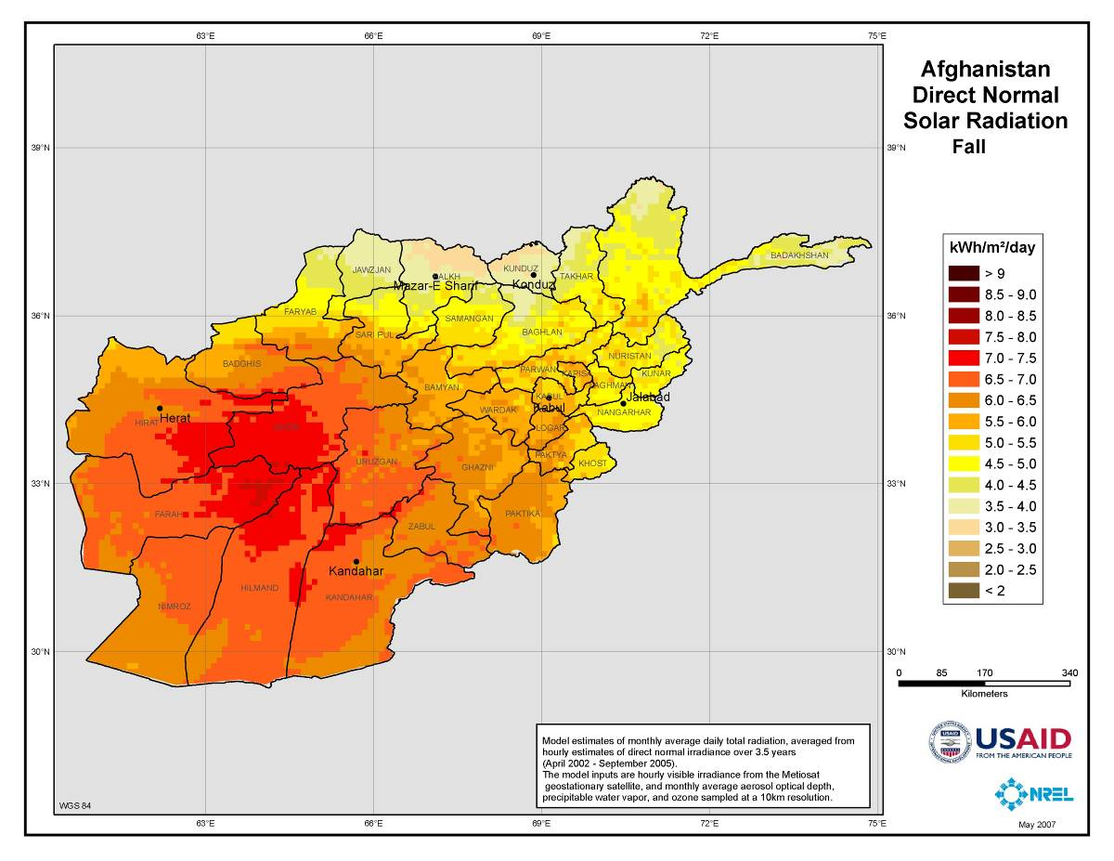
Source: USAID. Direct Normal Solar Radiation also is often referred to as Normal Direct Insolation (NDI)

Solar power systems in Afghanistan are receiving relatively low priority, primarily due to cost, but perhaps also because of cultural issues. In many applications, solar thermal approaches may be better than photovoltaics, but care must be taken with freezing. In the course of the STAR-TIDES demonstrations, a number of portable or transportable solar systems (some with integrated wind back-up) have been shown, as noted above. They have been high quality, rugged and can be chained together for scalability. Some are portable (easily transportable by donkey). But they may be too expensive for CDC projects (at least one of the integrated systems, producing about 1 kW-equivalent via solar and wind, runs about $10,000).
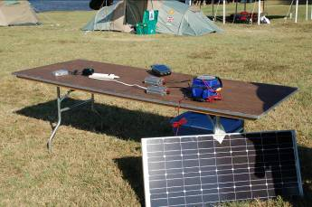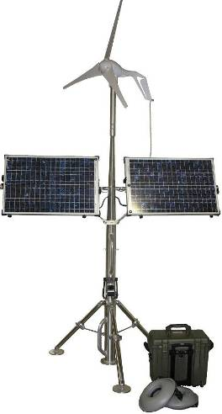

Simple solar panel with AA battery chargers Solar Stik integrated Solar/Wind System
Less expensive approaches have included simple photovoltaic panels charging AA batteries, which then are distributed to villagers for use as they desire--lighting, cooling fans, radios, cell phone chargers, etc.. Also, some of the OLPCs (One Laptop Per Child computers) have solar chargers.
Also worth of investigation are stand-alone LED lights with built-in solar cells that can be charged during the day and put in kitchens at night--the ultimate in integration between power generation and consumption. They're getting pretty inexpensive (less than $5 each in quantities of 20 at Costco). Some claim to generate twelve hours of light from seven hours of charging, but this needs testing under Afghan conditions.

See also the solar steam approaches discussed below under hybrids.

As with any of the approaches, buy-in from the villages is crucial. Not only may there be cultural issues with the transportable infrastructures, but solar panels and other pilferable equipment not protected by a sense of community ownership are likely to show up in local markets.

Hybrids

There are several interesting hybrid power generation models, such as diesel generator supplements to wind/solar systems. It’s not clear what the trade-offs would be in the Afghan context between the need to bring fuel to remote locations and the promise of more stable power, but hybrids can help cover peak loads and may only need to run a few hours a day. In many cases, they’re less expensive than adding more solar panels or batteries. As Tony Woods noted: “Once communities have reliable power for a period of time, and refrigeration and entertainment start appearing, then a much higher demand for reliability appears.” In any case, hybrid options are worth considering.

There also are many functioning biomass-to-electricity generators around the world. Given the extent of Afghan deforestation, this may not be the best place for such systems, but there might be some locations where it would be viable, such as driving pumps to irrigate agricultural land and feeding off the biomass in return. For example, a prototype is now in testing of a small, transportable steam engine driving an off-the-shelf 5.5 kW alternator that can generate 2-to-5 kW of electricity with relatively low temperature steam (2.2 kW on 160 degree C steam, 5 kW on 400 degree C steam) while using about 15 kg of fuel per hour. The generator also could run on solar or geothermal steam.

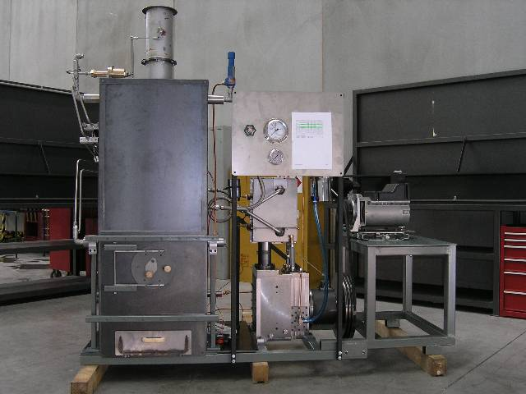
Pritchard Biomass-Fueled Steam Engine—the boiler’s about 5 feet high

One solar steam approach is an open source project under the Global Village Construction Set. The project aims to produce 3 kW of electrical output for $3k in material costs using concentrating mirrors and a reciprocating steam engine. It also envisions a fossil fuel hybrid when the sun’s not available.

Power Controllers

Power controllers have been an issue in Afghanistan. For example, energy can be used for commercial and educational uses during the day, house lighting at night, and water heating after everyone’s gone to bed. Many automatic electronic load controllers have needed considerable maintenance, but some villages have had good results with manual load-shifting switches, e.g. someone gets up at night and shifts power to the water heaters. However, but more reliable controllers reportedly are appearing.

Storage

Storage for the renewable energy systems is very important, especially for solar and wind, but also to make best use of microhydro. One low end model of energy storage and distribution that’s been developed for refugee camps involves the use of AA batteries for distribution to residents, as described earlier. A central village battery charger program could be tried as a pilot. There should be a nominal charge of a few Afs for the batteries to keep them from being taken for granted.

On a larger, but still portable scale, most of the integrated solar/wind energy systems have impressive battery packs that are portable, shippable as airline checked baggage, and are about equivalent to a 1 kW generator while discharging. They may be too expensive for rural Afghanistan but they could be useful in some applications.

Standard lead-acid batteries are one storage option, but deep cycle, designed-for-the-purpose batteries are needed. Thermal storage approaches, like the hot water systems noted above, could serve in some cases. If excess direct heat is available, from solar, geothermal or other sources, it could be used to heat rocks, bricks, or other objects that could be kept in insulated “retained heat” baskets and brought inside shelters at night to reduce the pulmonary and eye problems caused by burning fires in enclosed spaces.

Battery discharge also needs to be tested under Afghan winter conditions.

Geothermal

A 2004 survey of Afghanistan’s geothermal energy potential concluded: “The country has the potential of rapidly developing its geothermal resources for direct uses such as geothermal tourist and balneological [mineral bath] networks, greenhouse industry, food processing, fruits drying and processing, wool processing, carpet cleaning, and chemical applications. Though, development of geothermal resources for electric generation may not be a priority at this point, nonetheless, a large electrical power generation potential from geothermal resources is readily available for Afghanistan.”

Geothermal energy in Afghanistan could have many localized applications, including providing steam for some of the small steam-powered generators described above.

Integration

Since the focus of the overall project is to link the renewable energy systems to useful applications such as (a) water purification, (b) house lighting, (c) cool storage for agricultural produce if possible and (d) perhaps ICT, an important question concerns integration considerations (power quality, transmission distance, voltage, etc.).

Key questions include: what problem is trying to be solved? How can this lead to long term improvements in quality of life? How many people need service? How diffuse is the population? How far away from the user is the generator? What will the power be used for, when?

Chris’ team is working with the Agricultural Development Team (ADT) section at the Nangarhar PRT, and the Afghan Small and Medium Enterprise Development (ASMED) which connects loans and grants to entrepreneurs. SESA is working with the MRRD and MEW.

Power Uses

Water Purification

Clean drinking water is a problem in many parts of Afghanistan. There are several remedies, ranging from simple to very sophisticated.

If water can be heated above 65 degrees C, it can kill some forms of cholera, typhoid, hepatitis and e-coli. In many places water in black plastic bags put in the sun can reach 65 degrees C during the day (though I don't know about Afghanistan in winter). Beeswax melts at 67 degrees C, and so there are simple indicators available to show if the right temperature has been reached. This has the advantage of pasteurizing both the storage container and the water itself.

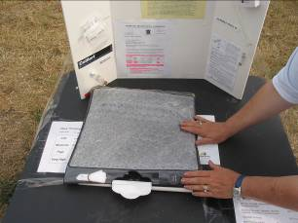

Black Plastic Bag for Pasteurizing Water in the Sun

US military medical teams are providing villages with saline solutions that they can use to reduce water pollution. In addition, there are commercial tablets such as Polar Pure. These are inexpensive and easy to use, but need to be restocked.

Other low cost solutions include portable microbiological filters such as LifeStraw, shown below. They typically are designed to prevent common diarrhoreal diseases, and can filter as much as 18,000 liters of water.

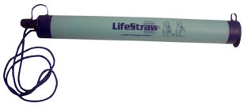
LifeStraw Water Filtration System

The Annapurna Conservation Area (ACA) in Nepal uses microhydro and solar photovoltaics to power small scale drinking water systems, and the team that designed and built them now is with SESA in Kabul.
The Western Hemisphere Information Exchange (WHIX) project, run out of Florida International University (FIU) in Miami and noted earlier, has developed a reverse osmosis purification unit that runs on 800 W or less to provide water for between 500 and 1500 people per day, depending on whether it’s run by solar or 24-hour power. This is less than a 5th of the power needed for normal units of this size. They also have developed water cleaning systems based on wetlands plants for Central America. Whether such systems might be suitable for Afghan environments is worth investigation.

Spetra Watermakers has a series of solutions for different conditions ranging from fresh water-to-fresh water (typically filtration), brackish-to-fresh, and salt water-to-fresh (reverse osmosis). Some of the ultra filtration systems are 900-lb units capable of cleaning 25,000 liters of water a day at relatively low pressure differentials. Others are transportable (108 lb) reverse osmosis systems working at much higher pressures, but drawing as little as 100 W to produce 150 or so gallons a day. Spectra has worked with WHIX.

Alrafadane is a company started by people with experience in Iraq (the name means "between the two rivers" in Arabic). It uses hollow-fiber ultrafiltration membrane techniques in portable containers to remove suspended particulates, colloidal material, bacteria and high molecular weight material greater than 0.1 micron.

WHIX, Alrafidane, and Spectra systems have participated in various STAR-TIDES demonstrations and tests. All have proved suitable for running off of solar or wind power units.

USAID has a new village-focused water program that’s intended to improve the long-term technical, financial and environmental sustainability of potable water supply and sanitation services and to improve hygiene behaviors for poor and vulnerable populations in Afghanistan. This program is in the procurement phase, so specifics are limited right now. The DAI (Development Alternatives International) company is under contract to USAID. They’ve done several projects to pipe water from springs to villages instead of digging wells. The water quality tends to be much better. There also is a USAID program to build a structured, and sustainable, commercial business model for water and sanitation service delivery in Afghanistan by encouraging the development of four Strategic Business Units (SBUs) across the country. The target SBUs are for Mazar-e-Sharif and Jalalabad, with smaller units in the capital cities of

Two excellent resources on water are Akvo (www.akvo.org), and Safe Water Network (www.safewaternetwork.org).

Lighting

Providing lighting to every Afghan house, school and business would have an enormous impact. It’s what people say they want most and one former Afghan cabinet minister described a light in every Afghan kitchen as being the most transformational single thing that could be done. Even stand-alone solar-powered lights at $5k each could be competitive. Some units claim to give up to 12 hours light on 7 hours charge—though I haven’t seen that kind of performance, and many it degrade over time. There also are “shake” flashlights that cost about $1 each and advertise 100 minutes of light for 1 minute of shaking. These are good subjects for testing.

In the STAR-TIDES tests, few solutions have proved suitable to all situations, but LED lighting has been the one infrastructure that has proved to be a winner in virtually all environments. It’s ultimately less expensive and longer lasting even than fluorescent bulbs, but the up-front costs for now are higher. It’s not clear how available LED lights are in Afghanistan.

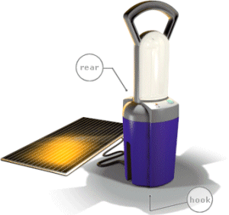
Fluorescent Lamp and Solar Charging Panel

Wind-up lanterns also could be effective. At $5/unit it would cost about $10k to light up a valley (district). However, if used outside the home, to light schools, for example, the solar or wind-up units would be vulnerable to being stolen, so the governance question remains central.

The Tolo-e Zanan-e Afghan (TZA—the sunrise of Afghan women) project assembles affordable solar lighting systems in Kabul, both to meet demand and to empower women. A key goal is to ensure that village systems can scale up beyond just lighting to provide a path to more robust development.

Reportedly, there’s an effective program in Helmand province installing solar powered lights in markets. But the Taliban are responding by destroying the lights.

Agricultural Storage

The review began by looking at how to preserve agricultural products in cold storage while waiting for movement to market. Most refrigeration systems are fairly power intensive, so this should be combined with an aggressive insulation and shelter design program as well. The DoD energy task force may have some ideas, as should ADT personnel at the PRTs.

One alternative suggestion was to consider root cellars, vice power-hungry cold storage. Another approach could be to use surplus refrigerated shipping containers already in Afghanistan (which are insulated and can be bought for a few thousand dollars) together with low-energy coolers.

Pat McArdle’s report from India, see below, outlined other uses for distributed energy, such as heating for greenhouses or to dry fruits and vegetables. Such heat could be generated by solar, biomass, or geothermal.

The whole issue of alternative crops, with different harvest times, and better storability should be the subject of a separate discussion.

ICT

If power were available, the uses for ICT could be virtually limitless. By and large, ICT systems don’t use very much power (a few hundred watts for a computer and wireless system), and a number of non-profit social enterprises, like Inveneo, and NGOs, such as the Jhai Foundation, are designing very low power computer and connection systems. The FabFi project (WiFi from the FabLab) represents an ongoing effort in the Jalalabad area to show the enormous potential of such connectivity.

Even if radio frequency connectivity isn’t available to remote villages, approaches like “Pony Express” (wireless clouds on buses, or diskette exchange via messenger) have been used successfully in places like Southeast Asia and demonstrations like STRONG ANGEL to get information to otherwise isolated people. WiMax systems offer longer ranges than WiFi.

The society-changing nature of cell phone penetration has been addressed in other papers accompanying this report, especially the pending impact on Afghanistan’s young people. To extend cell phone coverage beyond the normal range from towers, high gain antennas can be attached to cell phones to establish “Village Phones” in remote areas. This could be as transformational in Afghanistan as it’s been in places like Bangladesh. Power for the phones is crucial, but this need not await full village electrification. Wind-up chargers are available, though experience in some countries suggests they take too much winding to be effective. AA batteries and solar panels have worked in places. Even bicycle-powered battery chargers have been used.

Understanding the impact of ICT on remote environments, especially the information dimension, needs to be a priority for policy makers.

There also are a number of public heath initiatives based on low-bandwidth information sharing. The Assistant Secretary of Defense (Health Affairs) has several initiatives in this area, as do NGOs like InSTEDD (Innovative Support to Emergencies, Diseases and Disasters).

The One Laptop Per Child (OLPC) project also has a variety of charging mechanisms, ranging from wind-ups to solar panels.

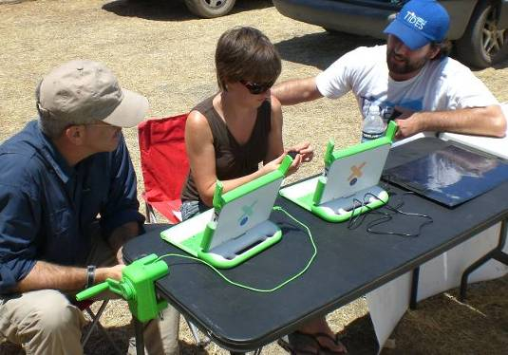

One Laptop Per Child

Related Areas

Integrated Cooking and Solar Food Processing
Integrated cooking refers to the combination of solar ovens, high efficiency combustion stoves and retained heat baskets to allow for cooking in all conditions while significantly reducing fuel use. Solar Food processing includes activities such as food drying and preservation.

Pat McArdle (solarwind1@mac.com) is a retired Senior Foreign Service Officer, and is involved in integrated cooking worldwide. She has been has been in Afghanistan, recently was in Nepal and attended the world Solar Food Processing Conference in India in January 2009. Pat has been a pioneer in integrated cooking and has been part of STAR-TIDES since its first meeting in Aug 2007. STAR-TIDES funded part of her travel to the conference. Below are excerpts from two of her recent e-mails

From Nepal:

“The Nepalese people are rapidly deforesting their country since most of them cook over wood fires burning 3 kg of wood/person/day. They most definitely need to know about solar cookers, fuel efficient stoves and retained heat cookers. It is unfortunate that our final demo, attended by more than 100 villagers, took place on the shortest day of the year. The shadows were very long, but we did manage to heat water enough to pasteurize it. [65 degrees C will pasteurize water] The sun was just too low in the sky to cook any-thing. Some of the women were a bit upset when we explained that the solar Hot Pot cooks more slowly than a fire, but most were very enthusiastic to learn about solar cook-ing technology and its potential to save wood and reduce their time in smoky kitchens.

Our final destination was Bhorley which the villagers said no American had ever visited. More than 100 people came to the demo. My Nepali colleague finally under-stands that these two hours demonstrations are not most effective way to introduce solar cookers, but his female field rep will follow up with the women in the villages where we demonstrated the Hot Pot. He is quite dedicated to renewable energy and sustainable development and should be very proud of his successful initiative to have the WWF introduce solar cooking into Nepal's national parks. FYI: Alcoa funded this project.”

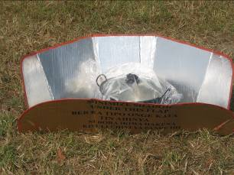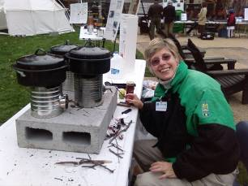
Inexpensive Solar Oven Combustion Stoves made from Coffee Cans

From India

Report to STAR-TIDES on the Solar Food Processing conference Indore, India Jan. 14-16, 2009.

Presentations and demonstrations at this conference, which was organized by the Solar Food Processing Network, were focused on simple solar thermal technologies for cooking food, and drying/boiling/ processing raw agricultural products.

The conference was sponsored by the International Solar Energy Society, Globosol, the Ministry of New and Renewable Energies of the Government of India and WISIONS Germany.

It was hosted by Jimmy McGillian, (recently awarded an OBE by Queen Elizabeth for his use of alternative energy in rural communities in India). Jimmy is the manager of Barli Institute for Rural Women.

The 100+ female students at the institute do all food preparation in a large integrated cooking kitchen on the roof of the classroom and dormitory building. The kitchen includes three Scheffler parabolic solar reflectors, which allow the student to boil rice and
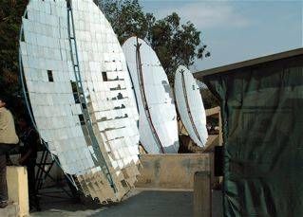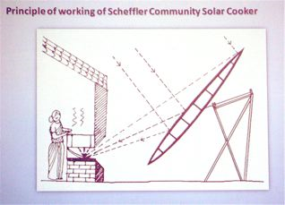

vegetables, fry food in hot oil, and cook chapatis on a solar-heated flat metal grill while working inside a clean, cool, smoke-free, kitchen.

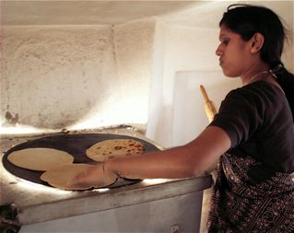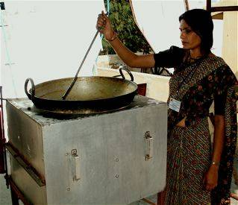

The institute also uses several SK-14 parabolic solar cookers on the rooftop patio outside the kitchen for cooking rice and boiling water.

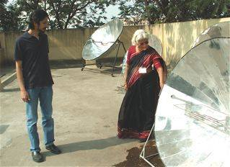

Barli has two insulated retained heat cookers in their kitchen to keep large pots of food hot for consumption at the evening meal.

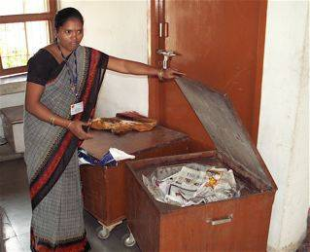

There is an iron heat storage unit, which is brought to over 400 degrees F. during the day by one of the Scheffler reflectors and used at night for cooking and boiling water.

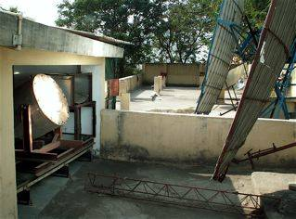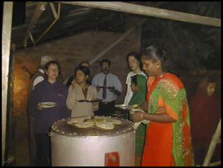

There is also a wood-burning, mud rocket stove built into the kitchen wall to supplement
the solar cookers during the monsoon season. It vents hot gasses and smoke outside and is fueled by fallen branches gathered from the trees around the institute.

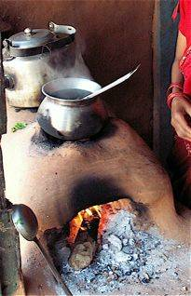

Austrian physicist Dr. Wolfgang Scheffler, who invented the Scheffler parabolic cooker and then freely shared his technology with the world, made a presentation on the innovative ways his design is being used in the developing world. The most impressive and successful commercial solar cooker promoters, who made several presentations at the conference were Deepak and Shirin Gadhia who run the ICNEER institute and Gadhia Solar Energy Systems. In the past 12 years their company has installed 27 large scale Scheffler solar thermal cooking and steam generating systems including a rooftop solar array for the Indian Army in Ladakh, Kashmir,

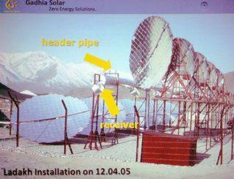

a rooftop system in Tirumala Tirupati that cooks 15,000 meals per day.

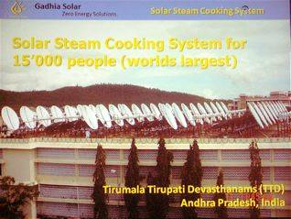

and an even larger solar steam kitchen system in Mt. Abu, which can cook up to 38,500 meals per day.

In addition to the many technical papers on solar thermal food processing technology presented at the conference, key issues discussed but still unresolved include:

- Why the leaders of energy-starved, sun-drenched developing countries continue to spend money subsidizing bottled cooking gas, while ignoring the potential of simple solar thermal technology.
- How to deal with the skeptical policy makers in donor and developing nations.
- Why large government-sponsored and international development agencies continue to dismiss solar cooking technology while focusing almost exclusively on fuel efficient stoves (FES) despite the shortcomings of FES programs, as detailed in a recent USAID study.
- How to deal with skeptical consumers. How to market solar food.
- Do government subsidies help or hinder the advancement of solar cooking and food processing technology.

Conferees agreed that there are currently no solar cooker organizations which have the capacity to upscale for a large project. Even in China which has almost 1.5 million solar cookers in use, the cookers have only been produced on a scale of tens of thousands. China was seen as a potential source for large scale production of inexpensive solar cooking and food processing technology. Conferees agreed that objective, international standards for solar cooker technology must be established so potential users can accurately and reliably determine which technology will work best for them.

There is enormous potential for solar cooking technology in Afghanistan, where surplus harvested fruits and vegetables are dried on flat mud roofs, exposing them to dust and animals. As I saw in Afghanistan, where there is little refrigeration and a limited transportation infrastructure, fruits and vegetables which could be dried and preserved are often left unsold to rot in market stalls during harvest season.

As the new U.S. administration explores ways to help Afghanistan stabilize its economy and move away from poppy production, solar cooking and food processing technology should be considered for wide-scale distribution. All the devices discussed in this report are currently being used in Afghanistan, albeit on a small scale and mostly with private funding. In August 2007 under the direction of Afghan engineer, Sabur Achtari, an experimental solar food processing center, Afghan Bedmoschk Solar Center (ABSC) was opened in Wardak province, with assistance from Heike Hoedt of Solar Brucke.

ABSC's initial focus was on the production of marmalade, dried fruits and cakes using Scheffler reflectors and solar tunnel food driers. ABSC dries and packages tomatoes, eggplants and apricots. The project has reached a stage where all problems with packaging have been solved. They import food grade plastic bags from Germany. The Afghan staff is now skilled at solar food processing and packaging but they still lack marketing skills.

While they are able to process dried fruits in large quantities, they continue to have trouble finding mason jars or their sterile equivalent with screw on tops for the marmalade which they prepare in large quantities using Scheffler solar cookers. This is an area where the U.S. Embassy, USAID and the Provincial Reconstruction Teams could provide additional assistance. ABSC currently has one solar food drying project financed by PRT Lograr. In Kunduz, the German PRT and the German aide agency GTZ are sponsoring an ABSC solar food processing project. According to Mr. Achtari, USAID through the PRTs has funded the construction and deployment of 42 of ASBC's model solar food driers. ASBC has also experimented with a solar heated tandoor oven, which bakes traditional Afghan bread using sunshine.

Mr. C.K. Rohatgi, of Rohitas Electronics, which produces the Tulsi Hybrid solar box cooker told me that the Department of Defense has purchased 40 Tulsis enameled with a desert camouflage design for testing. This purchase was a result of U.S.-based Tulsi Hybrid distributer Dave Chalker's demo at the Pentagon last fall with STAR-TIDES.

Michael Mueller (who did not present at the conference, but who recently began communicating with me) and his organization GHNI worked with a group of Afghans in Bamyan last summer to produce 100 concrete parabolic dish solar cookers. They sold them at a nearly self-sustainable cost of $60. This cooker brings 4 litres of water to a boil in 20 minutes between 11am - 2 pm, and at a slower rate earlier and later in the day (an ideal technology for Afghanistan's ubiquitous tea shops which consume large piles of wood every day).

The MIT Jalalabad FabLab, with which Dr. Dave Warner is involved, is also a potential source of new and better solar thermal designs that could be deployed in Afghanistan to both generate income for local manufacturers and help Afghans tap into their most abundant source of free energy--the sun (as demonstrated by NREL's SARI/E solar-wind mapping of Afghanistan).

This conference has clearly demonstrated the potential of simple, locally constructed, small and large scale solar thermal technology to: dramatically reduce fossil fuel and biomass consumption for more than a billion people; create jobs; and reduce indoor and outdoor air pollution.

I produced a YouTube video on solar cooking in Nepal and will be adding several more videos based on footage I shot at the conference.

My thanks to STAR-TIDES for funding this portion of my solar cooker trip to India.

Other Initiatives
Plans for remote villages also need to consider infrastructures such as shelter and, sanitation, but they were not part of this study.

The provision of public health to locations outside of the Kabul area also could have significant, near-term impacts. Mobile communications should be leveraged aggressively in support of public health. See, for example, the work by Dr. Akhila Kosaraju and COL Ron Poropatich, MD, under the auspices of the Assistant Secretary of Defense (Health Affairs).

Innovative approaches can provide essential services to the population and divide the Taliban from the people. Many of these need not be massively expensive, but they must be based on “bottom-up” initiatives and need to involve allies and coalition partners.

Way ahead:

Solutions for distributed energy and related applications can be approached systematically through a structured process:

- Postulate a desired end state for a village or region and success metrics, and lay
out suggested paths to them from initial scenario conditions.
- Postulate solution sets (combinations of energy sources and applications) that are
appropriate to each area and scenario.
- Identify coalition partners (shura, govt officials, NGOs, business, civil society,
etc.) who will have to live with, operate and sustain the solutions.
- Collaborate with the partners to refine the scenario, metrics, and solution sets into
approaches that meet their needs. Ideally, this approach can help local partners
improve the choices they adopt as “their” answers.
- Identify sources of supply for the solutions (government, non-government,
commercial, empowered citizens).
- Address legal and regulatory issues.
- Estimate resource needs and execute the plan.
- Work through field operating procedures to allow people to work together in
support of policies and other guidance.
- Develop training, exercise, and educational programs to increase effectiveness
and institutionalize lessons learned.
- Assess progress and adjust.

These processes should be institutionalized in conjunction with “bottom-up” approaches like the NSP.

Next Steps
- Identify quick-win projects in conjunction with stakeholders. Begin to identify partners through National Solidarity Program (NSP) channels. Afghanistan is a long-term campaign, but pay particular attention to projects that could bring capabilities to people in insurgent-prone areas before snow melt in mid-March to mid-April.
- Leverage the State Department’s work on microhydro power (MHP) in Nangarhar and public health initiatives, building on mobile phone technology.
- Identify innovative approaches and see if any are rapidly deployable in adequate numbers. Test using Naval Postgraduate School/SOCOM/ STAR-TIDES quarterly testing opportunities where feasible.
- Expand capacity-building approaches in Afghanistan in clean energy and related areas to (1) improve indigenous production capacity, (2) encourage entrepreneurial competition, and (3) provide technical training for managers and overseers.
- Find ways to sponsor a technical support unit (TSU) for MHP projects within the NSP framework to enhance technical proficiency and quality control.
- Seriously examine the potential for integrated cooking and solar food processing.
- Increase the integration of distributed energy plans, the build-out of ICT and access to information in remote areas with US and coalition objectives for stability, reconstruction and counterinsurgency.

Summary

Distributed, renewable energy can bring essential services to remote areas and contribute significantly to Afghan stabilization and reconstruction, as well as to the counter- insurgency campaign. Many early microhydro projects had reliability problems, but several successful approaches now can be used as nationwide models. Wind power is starting to be used, but solar still is nascent. Information-sharing about renewable energy is inconsistent. An information clearinghouse and reliable structures for technical support would be very useful.

Power in isolated villages can support applications such as water purification, lighting, agricultural activities, and ICT. Many solutions are available, so knowledge sharing and tech support will be essential to match them to local conditions. Integrated cooking (solar, combustion and retained heat) and solar food processing also deserve attention.

Even as local energy projects are implemented, plans should be made for national standards to facilitate connections to the overall power grid as it is built-out.

The near-term recommendations outlined above should be implemented.

Personnel Associated with Renewable Energy in Afghanistan
As of Feb 2009

ICE (Inter-Ministerial Commission for Energy (ICE) - Subcommittee for Renewable Energy and Rural Electrification.) All phone numbers are +93.
- H.E. Ahmed Wali Shirzay, MEW, Deputy Minister for Energy, 0799319505, Ah_w_shairzay@msn.com
- Amir Mohammad, MEW, Head of Renewable Energy in the Energy Planning Department, 0700218226, Alamzia_8226@yahoo.com
- Mir Sediq Ashan, MEW, Executive Director, ICE, icemir@yahoo.com
- Sjoerd Boersma, ISAF, Energy Analyst, 0799512419, sjoerd.boersma@hq.isaf.nato.int
- Bart Beltman, Emb. of Netherlands, Second Secretary Development Cooperation, 0700279193, bart.beltman@minbuza.nl
- Michael Gruber, KfW, Director, 0700274456 michael.gruber@kfw.de
- Haress Abaw, KfW, Advisor, 0700773698 haress.abawi@kfw.de
- Rodrigo Garza, American Embassy, Economic Officer, 0700108364, GarzaR@state.gov
- Glenn Whaley, USAID, Head of Energy Team, 0799794669, gwhaley@usaid.gov
- Abdul Rasool Wardak, USAID, Senior Engineer, 0700078676, rwardak@usaid.gov
- Dr. James Greer, MRRD, Special Assistant to the Minister, 0799843267, monty_greer@yahoo.com
- Azizullah Rahimi, MRRD, Director of Rural Energy and Economic Development, 0797437301, Rahimi.azizullah@gmail.com
- Ram Prasad Dhital, UNDPMRRD, Renewable Energy Expert, 0700996510, Ram.dhital@mrrd.gov.af
- Satish Gautam, UNDPMRRD, Energy Advisor, 0797418402, satish.gautam@mrrd.gov.af
- Robert Foster, AWATT/NMSU, Deputy COP, 0795996895, rfoster@nmsu.edu
- Tobias Becker, GTZ, Program Manager, ESRA, Secretariat, 0700661879, Tobias.becker@gtz.de
- Andre Moeller, DED, Advisor, ESRA, Secretariat, 0799014664, Moeller.andre@vdi.de

Others
- Lisa Magno, USAID, Deputy Director, OPPD, 0799 822 348, lmagno@usaid.gov
- Chris Corsten, Department of State, INL, chriscorsten@hotmail.com, Skype--chriscorsten
- Mark Hayton, Entec, mark.hayton@entec.ch
- Tony Woods, Sustainable Energy Services Afghanistan (SESA), 0708 373 215, twoods@sesa.af
- Pat McArdle, integrated cooking, solarwind1@mac.com

National standards are in place, but some parties involved in Afghan power generation work are not communicating with the Ministry of Energy and Water to obtain and use them.
Stand-alone solar-powered lights might be such a project, along with cell phone-based public health and some kinds of water purification, but capabilities must be matched to expectations.
Linton Wells II (WellsL3@ndu.edu, 202 436-6354), Center for Technology and National Security Policy (CTNSP), National Defense University (NDU), Trip Report, Afghanistan, 21-24 January 2009. Other papers from the visit include “Rationalization of Information and Communications Technology (ICT) Activities” and “Expanded Access to Information in Nangarhar Province.” The reports are intended to serve as stand-alone documents, but they have cross-references, so some of the material may be included in more than one paper.
Afghan Clean Energy Program (ACEP), concept paper, January 2009. USAID’s first Request for Proposals (RFP) will be issue in about March 2009, with work to begin in the summer. The focus will be on small, community-level projects in rural areas, and the first order of business will be to work with the Provincial Reconstruction Teams (PRTs) to identify candidate projects.
Low cost projects can wind up being very expensive if the quality is low. However, the community management aspects of these projects often are overlooked. If the community can’t read power meters (if they were installed at all), collect monthly bills, save for spare parts, or understand the need to pay for technological help, the project won’t succeed/ Human capacity shortfalls often are the biggest risks in projects, and developing these capabilities needs to be a part of the cost estimates.
TIDES stands for “Transportable Infrastructures for Development and Emergency Support” (part of the broader Sustainable Technologies, Accelerated Research effort). STAR-TIDES is an international, knowledge-sharing research project. It examines innovative approaches to public-private collaboration and “whole-of-government” solutions to provide sustainable, affordable support to stressed populations (post-war, post-disaster, impoverished). It leverages a worldwide network of people and organizations to conduct research and support real world contingencies.
The National Solidarity Program (NSP) began operations in 2003, financed by the Afghan Government with funds from the World Bank. The NSP provides block grants to villages across Afghanistan, “empowering communities to identify reconstruction and development priorities and implement projects in response…. To be eligible for the grants, villagers, both men and women, must elect a village Community Development Council (CDC), a quorum of the village must meet to reach consensus on priority projects, and accounts must be posted in a public place.” Source: Institute for State Effectiveness brochure, National Solidarity Program: A Hidden Success, 2008. As of October 2008, NSP had facilitated the election of more than 21,600 CDCs and guided the preparation of nearly 21,400 Community Development Plans (CDPs) in 351 districts and provincial centers. Since the Program’s inception, more than US$535 million in grants have been disbursed to rural communities, more than 25,100 projects have been completed and another 19,000 have been approved. The majority of these projects have been undertaken in the areas of water supply and sanitation, transport, irrigation, power supply, and education. In many remote parts of the country, NSP is the only functioning government development program. Source: Afghanistan Research and Evaluation Unit (AREU), The A to Z Guide to Afghanistan Assistance 2009, p. 51
The ISE (www.effectivestates.org) was founded in 2005 by Dr. Ashraf Ghani and Clare Lockhart to develop integrated approaches to state-building and provide independent, authoritiative and practical policy advice to the international community and and national leaders who are tasked with creating effective states in a globalized world. ISE’s support for the research on this report has been indispensible.
Islamic Republic of Afghanistan, Ministry of Energy & Water, Power Sector Strategy for the Afghanistan National Development Strategy (With Focus On Prioritization), April 2007. The report focuses on urban energy projects and acknowledges that “By 2022, as a result of the on-going and planned interventions, the rural coverage is estimated to increase to 65% of the total rural population. We recognize that providing rural electrification is a daunting challenge and there are no easy fixes.” The NEPS will allow the import of up to 150 mW of electricity from Uzbekistan. It is projected to begin operating at that level in July 2009, with the possibility of some electricity reaching Kabul earlier via NEPS facilities.
Drawn from a February 2006 report by Entec AG consulting & engineering, entitled Assessment & Recommendations for the Sustainable Implementation of Micro Hydro Power Projects in Afghanistan. Hereafter “Entec Report 2006.”
Entec Report 2006. The review visited a total of 10 MHP projects in the Panshir and Parwan provinces and 5 turbine manufacturing workshops, and included discussions with participants and reviews of documentation. The review also observed: “Normally the institutional (operational, management, financial etc) aspects of MHP project development represent a significant part of any stand alone rural electrification project. In the case of NSP, this institutional capacity building is an integral and fundamental part of the NSP project as a whole.”
NSP funds are managed by an Oversight Consultant (OC). The OC engineering department is ultimately responsible for approving all projects proposed by the CDCs, which are channeled through the Facilitating Partners (FPs—see below). The OC has engineers based at all of their provincial offices who are responsible for conducting first screening of project proposals.
Facilitating Partners (FPs) are either international or national NGOs contracted by NSP to implement projects throughout Afghanistan’s 34 provinces. Of the 25 FPs in 2006, approximately 15 were involved in implementing MHP projects.
Entec Report 2006, p. 4
Conversation with Chris Corsten, 1-20-09
Entec Report, 2006, op. cit
Doug Hall, Program Manager, Idaho National Laboratory Water Energy Program, e-mail to Mr. Johnny McNulty of ISE, Nov 14, 2008.
Data provided by ISE in a spreadsheet entitled “Nangarhar microhydro 9-08.xls.”
Nangarhar microhydro points.kmz. The key to the push pins on the overlay is: Red icons—surveyed possible microhydro point with no system currently built. Yellow icons--Microhydro system is present but could use some work to enhance its ability or it is poorly built and will need rehab. Green icons--Good microhydro system, fully functional. Blue/Purple icons—These are place holders for MHP sites Chris believes could be present. THESE ARE JUST GUESSES AND ARE NEITHER PRECISE NOR SURVEYED. The place holders will remain until the district they’re in has a full assessment to find each possible site. The next districts for assessment are Nazyan, and Kot, as well as finishing up Deh Bala. The next microhydros scheduled to be built will be the six in Momandara and six yet to be determined in Achin.
However, many cheap, locally available, compact fluorescent bulbs have no power factor correction, and aren’t very good.
Drawn from Entec Report 2006.
Chris Corsten brief entitled “Microhydro Power in Nangarhar.ppt”
Mark Hayton e-mail, 1-13-09
As noted elsewhere, low cost is no guarantee of success.
This seems barely enough to power productive uses.
There are philosophical differences over MHP designs. Some advocate low cost solutions such as earthen sluices and mud brick facilities to minimize up-front costs, while leaving the maintenance to the villagers. Based on the low long-term success rates of many past projects, this report supports higher up-front costs to procure more resilient systems, using Afghan labor wherever possible, vice outside contractors.
Source: Chris Corsten
By some accounts, only 5-10% of MHP projects across Afghanistan still are operating after two years.
Others argue that more expensive generators could reduce long term maintenance costs, but these are points on which reasonable people can differ.
One contributor might be the Center for International Private Enterprise (CIPE), a non-profit affiliate of the US Chamber of Commerce that promotes private enterprise and market-oriented reform (www.cipe.org). Other approaches include microcredit, like the Grameen Bank (whose www.grameen-info.org website on Feb 5, 2009 had been hijacked by anti-Israeli hackers).
Ministry of Irrigation, Water Resources and Environment, Watershed Atlas Of Afghanistan First Edition - Working Document For Planners, January 2004
ACEP concept paper, pp. 1-2
Dennis Elliott, Wind Resource Assessment and Mapping for Afghanistan and Pakistan, a study prepared under the NREL-USAID program South Asia Regional Initiative for Energy Cooperation and Development (SARI-Energy), June 2007. See also a global wind map from 3tier at http://firstlook.3tier.com/wind/ It’s not clear what season the map refers to. 3tier also reportedly is working on a map suited to hydro-electric projects. There also are excellent resources on wind and solar energy at the NRELwebsite for Afghanistan: http://www.nrel.gov/applying_technologies/applying_technologies_afghanistan.html
The ICE supports the MRRD and MEW.
Figures differ as to the output of the Darunta dam. Some say it now puts out only about 1 mW, although silt removal and turbine repair plans are underway to restore it to 12 mW capacity. Others say that it can generate about 8 mW now. In any case, the demand for power in Nangarhar provinces is estimated at around 200 mW.
SESA also worked also on a small wind farm (100 kW) in Panjshir.
For example, Solar Stik, Skybuilt Power and Compass Energy. Participation in STAR-TIDES does not imply endorsement by the US government.
ACEP Concept Paper, p. 1
Scatec Solar, Solar Energy for Development: Scatec Solar’s Community Solar Power Plants, Briefing, 1/2009.
For comparison purposes, 1 liter of diesel is equivalent to about 3 kWh. Thus a 10 kW generator will consume about 3.3 liters of fuel per hour. Since diesel fuel in Afghanistan costs about $1 per liter (not including costs of distribution to remote areas, force protection, environmental degradation, etc.) generator-driven power costs $.30 to $.40 per kWh.
Comments on an earlier draft of this paper, Feb 8, 2009.
See the article “Full Power, Four Ways,” in the November 2008 issue of the magazine Diesel Progress North America at http://www.dpna-digital.com/dpna-sample/sample/, as well as the general www.dieselprogress.com website. The article describes the Remus system developed for the US Defense Logistics Agency (DLA), a combined diesel, wind, solar, and rechargeable battery approach producing 60 kW from the diesel, 400 W from wind, 3.26 kW and from solar, with 30 Amp, 300 Vdo batteries. The system also includes a 7.5-ton air conditioner and a water purification system that can deliver 3,600 gal/day. Remus consumes 2.8 gallons of diesel per hour at 75% load. At 6,500 pounds and about 16 feet long, this is probably not suited for remote Afghan villages, either from a size or a sophistication point of view, but it suggests what can be done with integrated packages.
See, for example, those developed under the Western Hemisphere Information Exchange (WHIX). www.asaie.army.mil/Public/IE/doc/WHIX_Executive_Summary.pdf.
http://www.pritchardpower.com.au/ The Pritchard Power looks to be aiming at about $2.60/W and be available in production quantities in 2 years.
http://openfarmtech.org/weblog/?p=406 The system uses flat mirrors to avoid the manufacturing complexities of parabolic systems.
Saba, D.S.; Najaf, M.E.; Musazi, A.M.; and Taraki, S.A.: Geothermal Energy in Afghanistan; Prospects and Potential, prepared for Center on International Cooperation, New York University and Afghanistan Center for Policy and Development Studies, February 2004, p. 25
Understanding the nature of the pollution is important in designing the solution. For example, filtration systems can address very small particulate materials, but not dissolved materials such as arsenic or pesticides. Pasteurization approaches kill some kinds of diseases, but not others. Solutions need precise information about the local impurities.
www.lifestraw.com
www.spectrawatermakers.com
www.alrafidane.net.
Participation in STAR-TIDES does not imply endorsement by the US government.
Lisa Magno, USAID Afghanistan, e-mail Feb 11, 2009.
Sustainable Energy Services Afghanistan, Khoshal Khan Meena, Opposite Central Silo, 3rd floor of Haji Mirwis Apartment, District 5, Kabul. Tel 0779018085, 0708373215
http://www.inveneo.org/
http://www.jhai.org/
http://fabfiwireless.blogspot.com/ See also the paper in this series on “Expanded Access to Information in Nangarhar Province.”
See, for example, www.strongangel3.net
The Grameen Foundation’s “Village Telephone Direct Manual” describes the elements of this program, and the Foundation’s “Village Phone Replication Manual” describes in detail the 14 steps needed to evaluate the suitability of alternative environments for Village Phone, and then to implement the projects as appropriate.
http://instedd.org/ From InSTEDD’s website: “We want everyone to benefit from the tools and technologies we know can save lives. We want those technologies to work anywhere, any time, under the harshest conditions.”
See report on “Expanded Access to Information in Nangarhar Province.”

